South Yorkshire Pension Authority
Background Information
Appointment of Employer Representative to the Local Pension Board

About South Yorkshire Pensions Authority (SYPA)

SYPA is the public body created in 1988 to manage the South Yorkshire Pension Fund which is part of the Local Government Pension Scheme (LGPS). The full Authority is made up of 12 councillors appointed by the 4 district councils (Barnsley, Doncaster, Rotherham and the City of Sheffield). We have around 130 staff based at our headquarters in Barnsley.

Our pension fund had assets of around £11bn at the end of March 2024 and looked after the pension savings of around 180,000 members and 600 different employing organisations including an increasing number of non teaching staff at Academy schools.

The Authority’s work is organised around three key streams of activity as shown in the chart below:
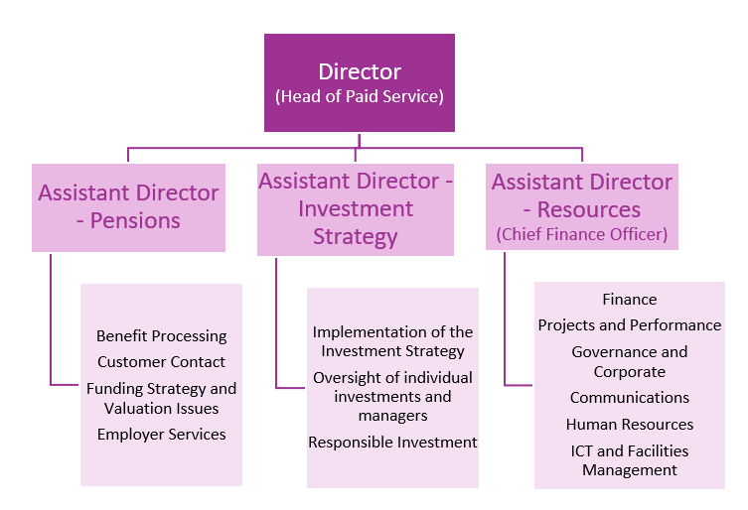

The statutory roles of Monitoring Officer, and Chief Finance Officer (S.73 officer) are carried out by the relevant officers within South Yorkshire Pensions Authority.

The diagram below shows how the different elements of our governance arrangements fit together and how they relate to the various elements of the Border to Coast Pensions Partnership in relation to investment matters.
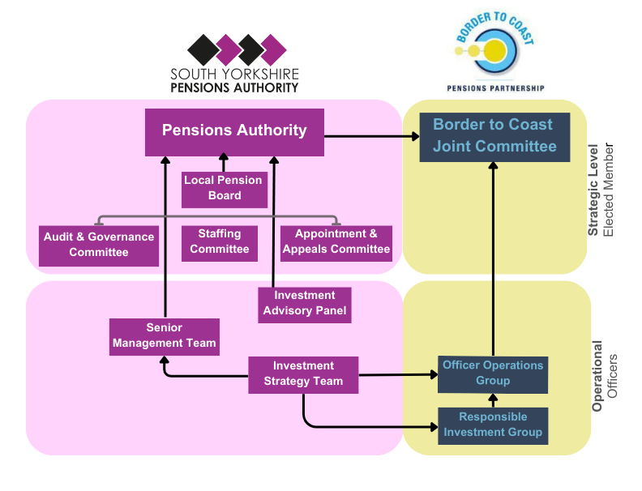

Corporate Objectives

SYPA operates to deliver a number of corporate objectives the achievement of which will allow us to deliver on our mission which is:

To deliver a sustainable and cost-effective pension scheme for members and employers in South Yorkshire delivering high levels of customer service and strong investment returns which facilitate stable contributions.

We only exist because of our customers and given that we only do one thing, run the pension scheme, we owe it to them to provide the best possible performance while maintaining costs within reasonable levels.
In order to achieve this mission, there are a number of things we need to do, our objectives, which are:
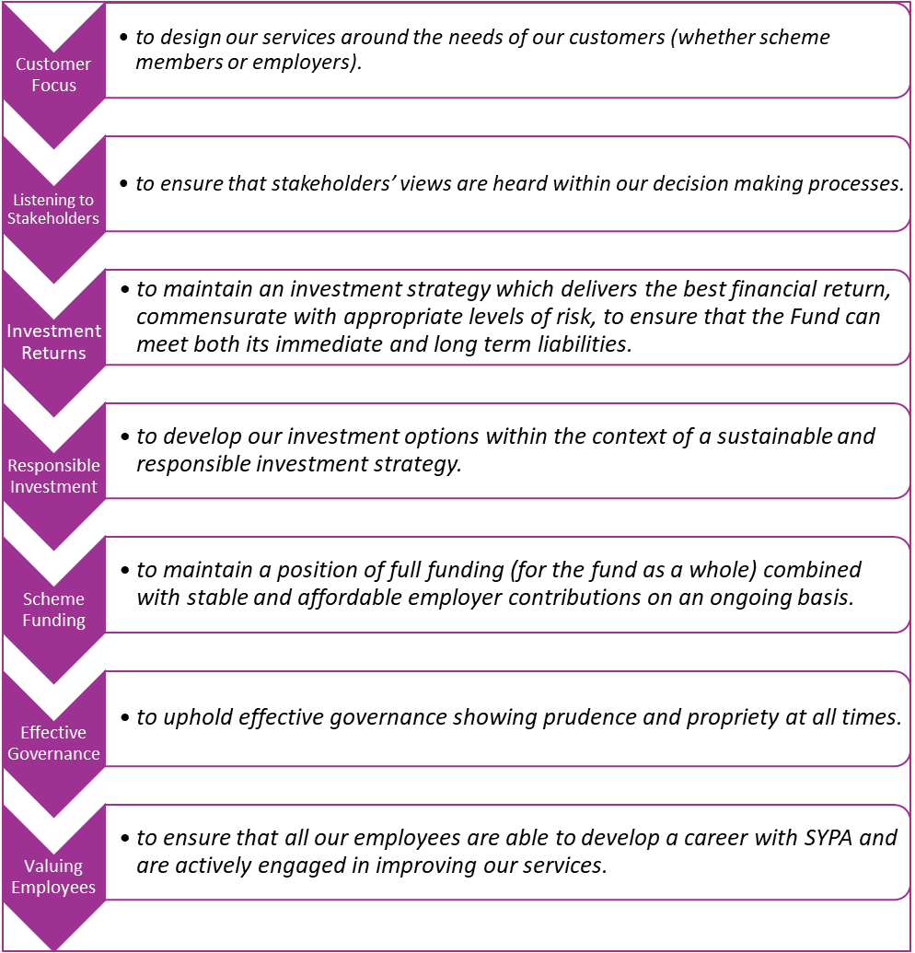

How we achieve our objectives is as important to us as what we achieve, and we operate with a framework of values and behaviours which signify the type of organisation we want to be:
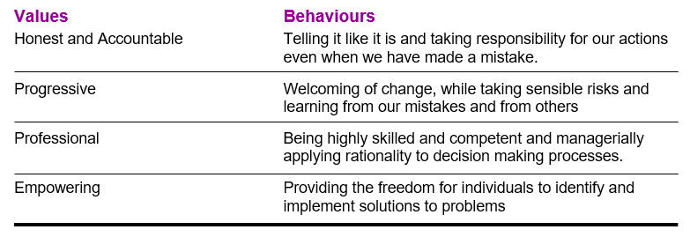
Key Events in 2023/24

2023/24 has been another busy year for the Authority with a number of key events:

- The implementation of the results of the three yearly valuation of the Pension Fund by our actuary Hymans Robertson, which concluded that strong and consistent investment performance had delivered a surplus of assets over liabilities for the first time since at least the 1990’s. This has allowed us to provide greater long-term stability to employer contributions.
- Implementation of a revised investment strategy including changes designed to enable us to accelerate the rate of progress towards our investment portfolios becoming Net Zero.
- Completion of Project Chip – one of the largest ever UK agricultural land transactions (at £260m) which in partnership with Royal London turned our agricultural land holdings into a natural capital investment within a structure capable of being invested in by other institutional investors.
- The agreement of a medium-term resourcing plan designed to ensure that the Authority has sufficient staff resources to maintain a sustainable organisation and to deliver the quality-of-service members rightly expect going into the future.
- The continued growth of our Place Based Impact Investment portfolio focussed on investment in South Yorkshire.
- Improving the quality of our communication with scheme members using more modern approaches through social media and also more traditional means such as our regular newsletters.
- Alongside all these important developments we are also paying attention to the corporate infrastructure with an emphasis on delivering a range of improvements to our governance and ensuring we have the resources and tools needed to deliver on the corporate strategy.

About the Local Pension Board

The role of the Local Pension Board, as defined by Sections 5(1) and (2) of the Public Service Pensions Act 2013, is to assist the Authority in the following matters:
- securing compliance with the scheme regulations and other legislation relating to the governance and administration of the scheme;
- securing compliance with requirements imposed in relation to the scheme and any connected scheme by the Pensions Regulator;
- such other matters as the scheme regulations may specify.

South Yorkshire’s Local Pension Board consists of 10 members (5 scheme members and 5 employers) with the seats determined as shown below:

Employers:
2 Local Authority Councillors
3 Employer Representatives appointed to achieve a balance of interests

Scheme Members:
1 GMB Representative
1 Unison Representative
1 Unite Representative
2 Scheme Members

The Board meets four times per year and papers for the meetings can be found at the following link:
Governance (sypensions.org.uk)

The annual report of the Local Pension Board is included within the Authority’s annual report which is available in the documents section of our website page here: SYPA In Focus and the Constitution of the LPB is available here:
Local Pension Board Constitution.

Further information about all aspects of the Authority’s work is on our website at the link below:
http://www.sypensions.org.uk/

If you have any queries or would like to arrange a call to discuss the role further, please contact Head of Governance and Corporate Services, Jo Stone, at the following email address: governanceteam@sypa.org.uk

